3. House Number

Tvarditsa,Sliven district, Kozarevo borough,18 Haydushka Polyana str.

GPS N 42º42’01.0” and E 25º52’21.6”

The house is with 2 floors without basement. The first floor is half underground. The connection between the first and the second floor is with external stairs.

The toilet and bathroom are outside.

4 MDC – yellow and 4 MCH – black. 3 CATS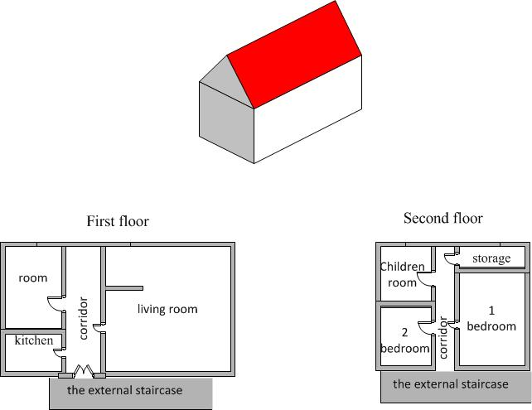

E-perm

pair of CATS

relevant GTS